**CSD 317 : Introduction to Database Systems**

**Project Report: COVID19- Vaccination Tracking System**

**From:** [**Lakshya Mishra**](mailto:lm712@snu.edu.in) **,** [**Suvrat Matanhelia**](mailto:sm577@snu.edu.in) **and Aden Mathew**

## **Project Description**

This project focuses on building a **COVID-19 Vaccination Tracking System**, a database-driven application designed to manage vaccination records, citizen health data, vaccine distribution, and real-time monitoring. The system provides functionalities for:

* **Citizen registration & priority group classification**
* **Vaccination scheduling & dose tracking**
* **Vaccination center management & inventory control**
* **Health monitoring & certificate generation**
* **Analytics dashboards for government and healthcare officials**

The system ensures **data security, privacy, and real-time reporting** to support pandemic response efforts.

## **Technologies Used**

* **Backend**: MySQL (Relational Database)
* **API Integration**: (Optional) Government ID verification APIs (e.g., Aadhaar/Passport validation)
* **Analytics**: SQL Views & Stored Procedures for real-time reporting

## **Features**

### **1. Citizen Registration & Management**

* Secure registration with **name, age, gender, ID proof, address, and medical history**.
* Priority classification (e.g., senior citizens, frontline workers).
* **Multi-factor authentication** for sensitive data access.

### **2. Vaccination Scheduling & Tracking**

* **Appointment booking** with preferred vaccination centers.
* **Dose tracking** (1st, 2nd, booster) with reminders.
* Batch number and vaccine type (Covishield, Covaxin, etc.) tracking.

### **3. Vaccination Center Management**

* **Center details** (location, capacity, working hours).
* **Real-time slot availability** based on inventory.
* **Staff assignment & workload tracking**.

### **4. Vaccine Inventory & Distribution**

* **Stock management** (received, used, expired doses).
* **Distribution logs** from central warehouses to regional centers.

### **5. Health Monitoring & Reporting**

* **Post-vaccination symptom tracking**.
* **COVID test result integration**.
* **High-risk case flagging**.

### **6. Certificate Generation**

* **Digital certificates with QR codes** after full vaccination.
* **Verification system** for authenticity checks.

### **7. Analytics & Dashboards**

* **Vaccination rates by region**.
* **Infection vs. vaccination trends**.
* **Demographic coverage reports**.

### **8. Security & Privacy**

* **Role-based access control** (Admin, Healthcare Worker, Citizen).
* **Encryption** for sensitive data (Aadhaar, medical records).
* **Audit logs** for all data modifications.

## **Limitations**

* **No direct integration with government health portals** (manual data entry required).
* **No real-time SMS/email notification system** (currently relies on backend logs).
* **Limited mobile accessibility** (optimized for desktop use).

## **Future Scope**

1. **Web & Mobile App Integration** – Expand accessibility for citizens and admins.
2. **Automated Government Data Sync** – Reduce manual entry via API integrations.
3. **Real-Time Alerts** – SMS/email notifications for appointments and dose reminders.
4. **AI-Powered Risk Prediction** – Analyze health data to flag high-risk individuals.
5. **Blockchain for Certificate Security** – Prevent forgery of vaccination records.

## **ER DIAGRAM**

## 

## 

## 

## 

## 

## 

## 

## 

## **Relational Model Diagram**

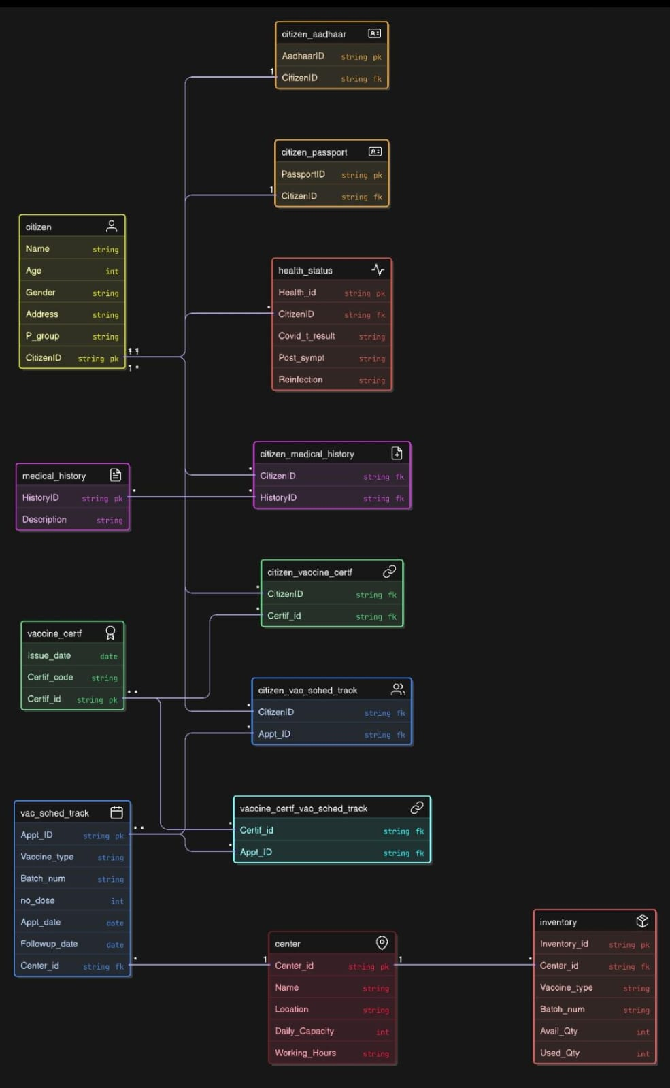

## **Final Tables after Normalization**

### **1. Citizens Table**

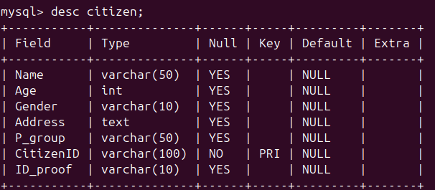

### **2. Vaccination_Sched_and_Track Table**

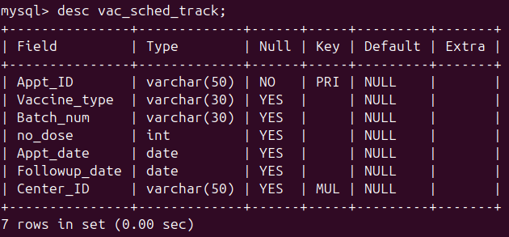

### **3. Vaccination Centers Table**

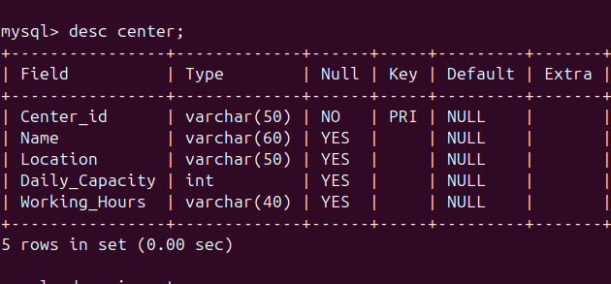

**4. Inventory**

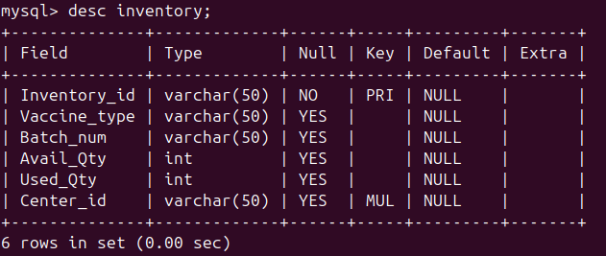

**5. Medical_History**

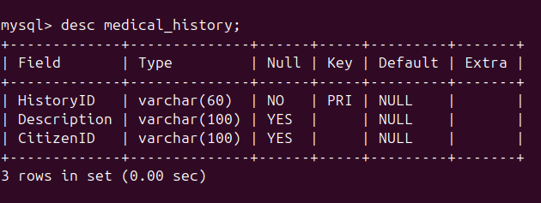

**6. Health Status**

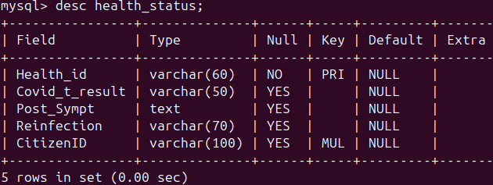

**7. Vaccine Certificate**

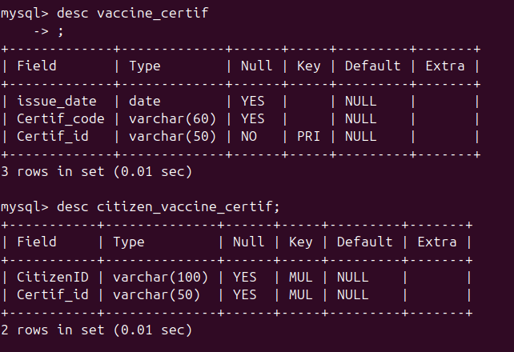

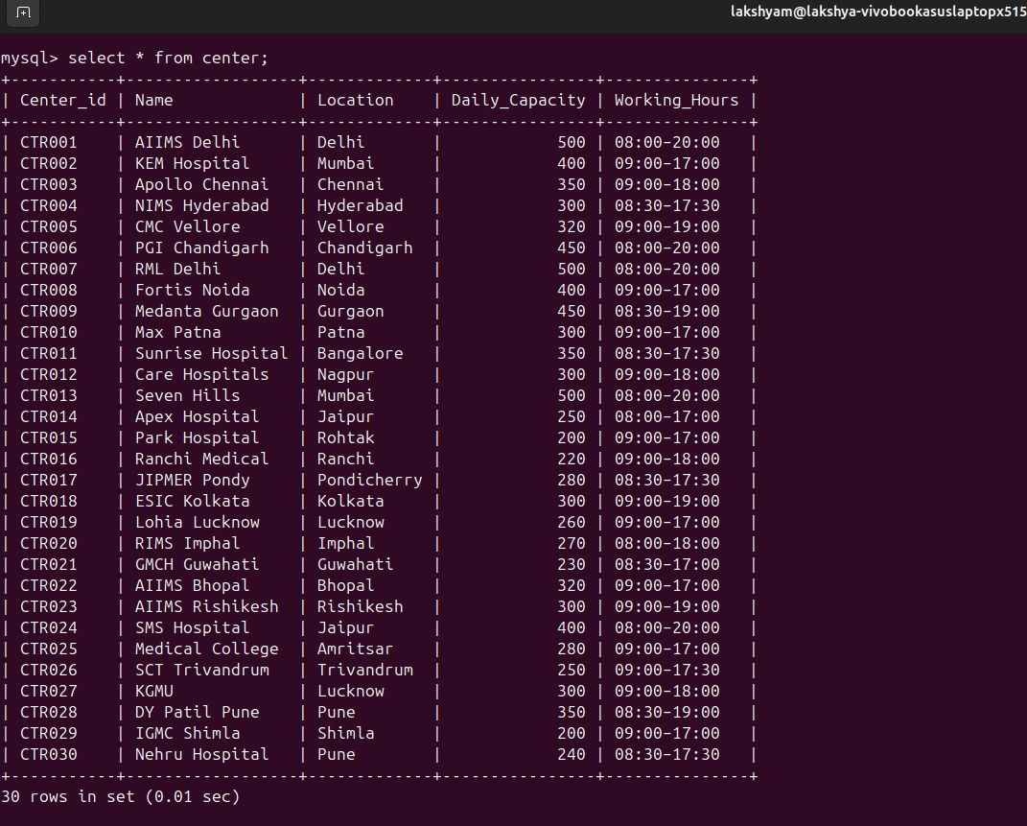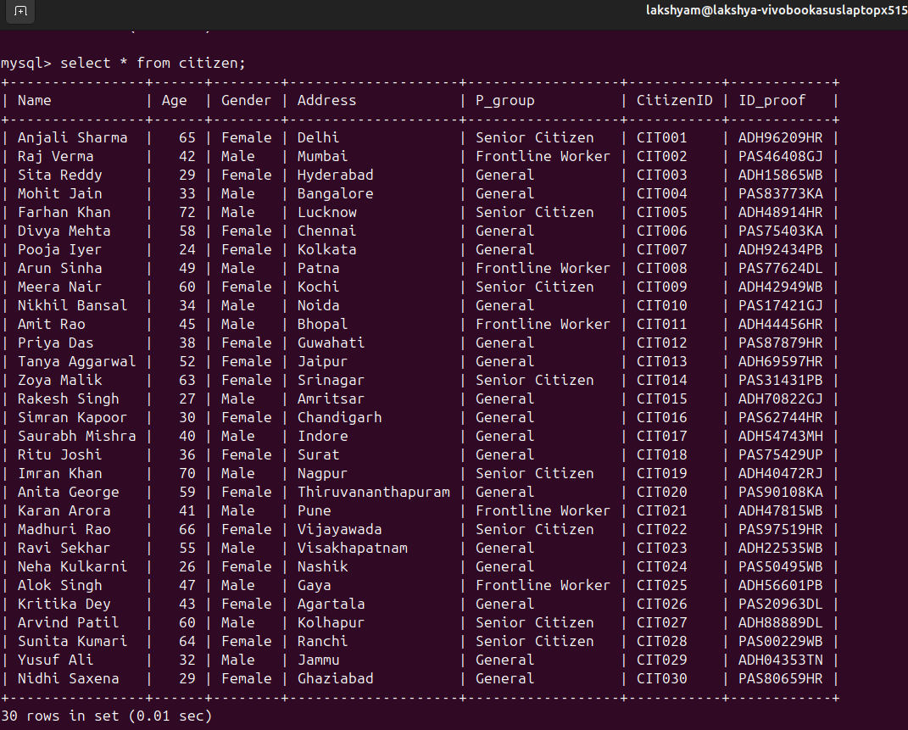

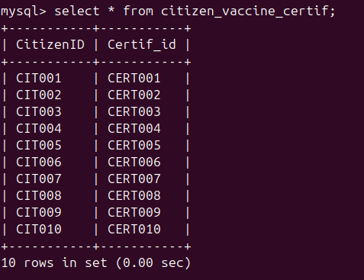

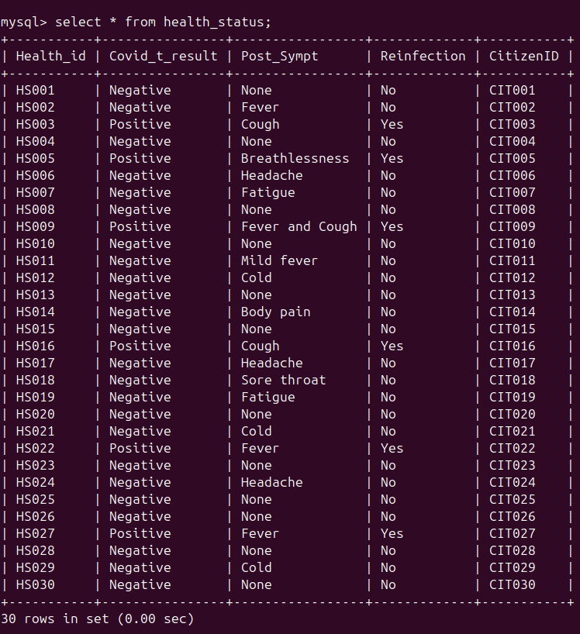

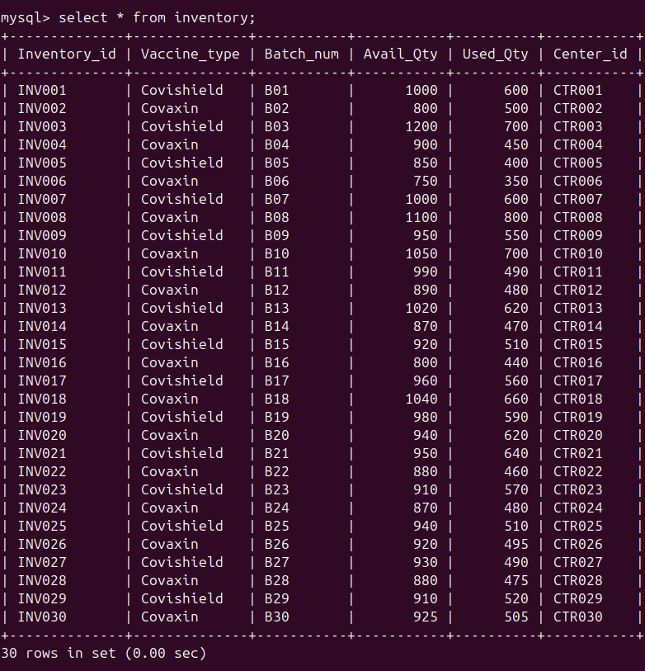

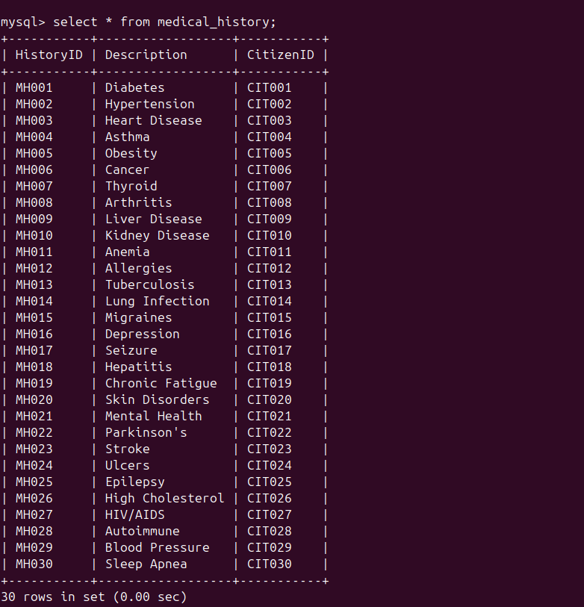

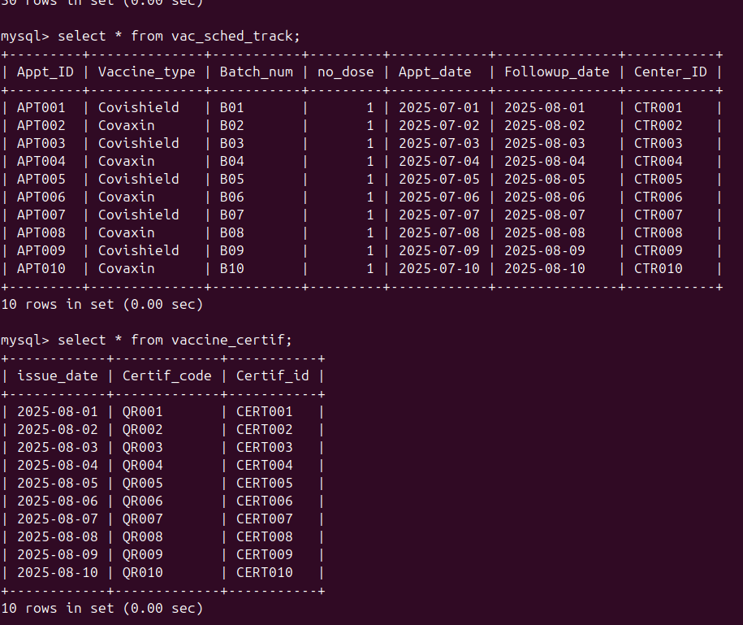

**MySQL Table Queries :**

**create table citizen(Name VARCHAR(50),Age INT, Gender VARCHAR(10),Address TEXT,P_group VARCHAR(50),CitizenID VARCHAR(100) PRIMARY KEY);**

**create table health_status(Health_id VARCHAR(60) PRIMARY KEY,Covid_t_result VARCHAR(50),Post_Sympt TEXT,Reinfection VARCHAR(70),CitizenID VARCHAR(100), FOREIGN KEY(CitizenID) REFERENCES citizen(CitizenID));**

**create table medical_history(HistoryID VARCHAR(60) PRIMARY KEY,Description VARCHAR(100));**

**create table vaccine_certif(issue_date DATE,Certif_code VARCHAR(60),Certif_id VARCHAR(50) PRIMARY KEY);**

**create table citizen_vaccine_certif(CitizenID VARCHAR(100),Certif_id VARCHAR(50),FOREIGN KEY(CitizenID) REFERENCES citizen(CitizenID),FOREIGN KEY(Certif_id) REFERENCES vaccine_certif(Certif_id));**

**create table center(Center_id VARCHAR(50) PRIMARY KEY,Name VARCHAR(60),Location VARCHAR(50),Daily_Capacity INT,Working_Hours VARCHAR(40));**

**create table vac_sched_track(Appt_ID VARCHAR(50) PRIMARY KEY,Vaccine_type VARCHAR(30),Batch_num VARCHAR(30),no_dose INT,Appt_date DATE,Followup_date DATE,Center_ID VARCHAR(50),FOREIGN KEY(Center_ID) REFERENCES center(Center_ID));**

**create table vaccine_certif_vac_sched_track(Certif_id VARCHAR(50),Appt_ID VARCHAR(50),FOREIGN KEY(Certif_id) REFERENCES citizen_vaccine_certif(Certif_id),FOREIGN KEY(Appt_ID) REFERENCES vac_sched_track(Appt_ID));**

**create table inventory(Inventory_id VARCHAR(50) PRIMARY KEY,Vaccine_type VARCHAR(50),Batch_num VARCHAR(50),Avail_Qty INT,Used_Qty INT,Center_id VARCHAR(50),FOREIGN KEY(Center_id) REFERENCES center(Center_id));**